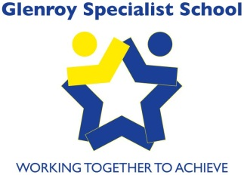
Glenroy Specialist School
Working Together To Achieve

Physical Contact Policy

Creation Date: June 2017
Review Date: June 2020

Aims:

- To acknowledge that physical contact has a role in the development and implementation of appropriate learning objectives.
- To allow for safe and appropriate physical contact as part of positive human interaction
- To provide a safe environment for both students and staff in situations where physical contact is unavoidable

Understandings:
- Physical contact must be educationally defensible, necessary and appropriate to the needs and the developmental/chronological age of the student.
- Physical contact between student and adult may occur in the context of play/conversation.
- The personal, medical and learning needs of students often require physical contact. Behaviour Support plans, personal care plans, Transfer profiles and Mealtime profiles contain clearly identified actions for staff in their interactions with individual students
- At Glenroy Specialist School physical contact may include:
- greetings
- administering first aid.
- consoling or encouraging in non-intrusive ways e.g. pat on the shoulder.
- interacting with students as part of their learning programs e.g. Aquatics, gross motor activities, mobility, individual sensory programs
- helping with dressing, changing clothes, toileting, seating and positioning, and other personal care needs.

Implementation:

- Staff must be aware that legislation focuses on perceptions of the contact and not on the intentions of the staff member providing this contact; and so avoid situations where contact is inappropriate or may be perceived by the recipient or others as inappropriate, embarrassing or uncomfortable.
- Wherever possible staff should avoid being alone with a student. Where this is not possible, and when the needs of the student dictate the need to be alone with them, staff must ensure that others are informed and the door of the room is ajar.
- When undressing a student, 2 staff members must always be present.
- Where appropriate, staff should always seek the student’s permission to make physical contact and explain to them what contact is involved.
- Except where specifically identified, physical contact can only be made to the face, hands, arms, shoulders, lower legs and upper back.
- Staff should acknowledge physical contact from students but not unnecessarily sustain the contact. If the student’s contact is inappropriate for any reason, including age-appropriateness, the staff member should discontinue and discourage it immediately. If this contact is regular and on-going, the student’s Behaviour Support plan should be reviewed to address this.
- Staff should use various modes of communication that are relevant and meaningful for a particular student when initiating contact e.g. hand shake, hi-5 or rub on forearm.

Related information:
Glenroy Specialist School’s Child Safe processes and procedures.

Evaluation:

- Review: Triennially.

- Ratification by School Council: June 2017

