Scope:
This policy applies to all employees, students, visitors, volunteers and contractors in Department of Education and Training (DET) workplaces.

DET Occupational Health and Safety (OHS) Commitment and Principles:
DET values its people and recognises that health and safety is integral to achieving excellent educational and work performance outcomes.
DET is legally and morally committed to providing employees, students, contractors and visitors with a healthy and safe working and learning environment.
DET will so far as is reasonably practicable, take action to improve and promote OHS to prevent workplace injuries and illnesses at all DET workplaces.

Policy Objectives:
DET is committed to:
- consulting with employees and their representatives, so far as reasonably practicable, on OHS decisions and changes that affect their workplace
- reducing OHS risks through a documented process of hazard identification, assessment, implementation and review of controls
- complying with relevant legislation, DET procedures and guidelines relating to OHS
- provision of a clear statement of OHS accountabilities and responsibilities for personnel across the organisation
- strengthening leadership capability and accountability for OHS across DET
- maintaining, monitoring and reviewing the OHS management system to ensure it is consistent with the nature and risk profile of DET operations
- actively supporting the physical and psychological wellbeing of DET employees by providing access to specialist OHS advice and services
- monitoring, reporting and responding to OHS performance outcomes to drive continuous improvement
- allocating adequate resources to maintain healthy, safe and supportive workplaces
- providing appropriate OHS information and training for all DET employees to enable them to perform their roles and responsibilities safely
- reporting and investigating incidents where appropriate and acting to prevent re-occurrence.

DET employees, visitors, volunteers and contractors are required to:
- take reasonable care for their own OHS and act in a manner that does not put others at risk
- actively contribute to identifying, reporting and reducing OHS hazards and risks
- cooperate with DET on OHS matters including following DET procedures and participating in consultation and training.

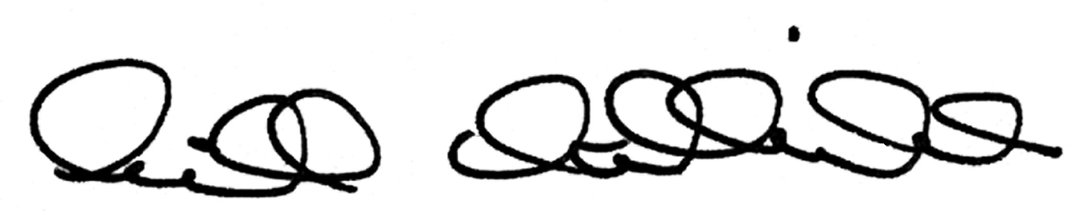
Gill Callister
Secretary
5/5/2015

